PURPOSE

The purpose of this Best Management Practice is to ensure that all asbestos containing materials at Freeport-McMoRan Morenci Inc. (Morenci) are handled and disposed of properly and in accordance with all applicable rules and regulations.

SCOPE

Asbestos is a naturally occurring mineral. It is distinguished from other minerals by the fact that its crystals form into long, thin fibers. Deposits of asbestos are found throughout the world.

Asbestos minerals are divided into two groups – serpentine and amphibole. The distinction between groups is based upon its crystalline structure – serpentine minerals have a sheet or layered structure, amphiboles have a chain-like structure.

Serpentine group has one type called chrysotile, which is the most commonly used type of asbestos and accounts for approximately 95% of the asbestos found in buildings. Chrysotile is commonly known as “white asbestos”, so named for its natural color.

The second most likely type to be found in buildings is amosite from the amphibole group. This type is often referred to as “brown asbestos”, because of its natural brown color. Next is crocidolite, “blue asbestos”, which is also in the amphibole group and commonly found in high temperature insulation applications. There are three other types that are extremely rare and have little commercial value and are not expected to be found at Morenci.

Asbestos has been used in literally thousands of products. Asbestos is plentiful, readily available, low in cost, and has unique properties – it does not burn, it is strong, conducts heat and electricity poorly, and it is impervious to chemical corrosion. Fireproofing is one of the most common uses. Asbestos is added to a variety of building materials to enhance strength. It can be found in pipe insulation, wire insulation, cement, asphalt, vinyl, roofing shingles, wallboard, partitions, pipes, roofing felts, floor tile, joint compounds and adhesives to name a few.

PROCEDURE

WHAT DO I DO WHEN I GENERATE OR FIND ASBESTOS CONTAINING WASTE THAT NEEDS TO BE DISPOSED OF?

Follow procedures outlined in BMP No. 301 – Demolition & Renovation Notification.

Follow guidelines outlined in Blue Stake Procedures for wall and floor penetrations.

No material shall be deposited in the asbestos disposal site without first notifying the Environmental Services Department. Under no circumstances are any other materials to be mixed with asbestos containing materials.

- The key to the Asbestos Disposal Site must be checked out at the Environmental Services Office.

- Obtain weight of the asbestos by weighing in and out at the Gate.

- A logbook shall be maintained in the Environmental Services Department office and filled out by the individual picking up the key & delivering the asbestos containing material to the Asbestos Disposal Site.

- Material deposited in the Asbestos Disposal Site must be taken and unloaded in the designated area, signs are located at the site to mark the proper location. Under no circumstances should asbestos be placed in any area other the signed area. Contact Environmental Services office at 865-6000 if sign is missing or if clarification is needed.

- Regulated asbestos containing material shall be:

- double bagged with 6mm polyethylene bag or plastic sheeting and sealed
- labeled with the appropriate Asbestos wording (see Figure 1 below)
- DOT Class 9 diamond with NA2212 (see Figure 2) and
- marked as to its source
prior to delivery to the Asbestos Disposal Site.

Return the Asbestos Disposal Site key to the Environmental Services Personnel immediately following the disposal activity along with the weight ticket(s). Signing off in the logbook is also required. Individual(s) returning the key to the Environmental Services office must make verbal contact with a member of the Environmental staff.

NOTE: the Asbestos Disposal Site key will not be released after 3pm to allow ample time for completion of the day’s disposal procedures.

- Verbal contact must also be made to the Environmental staff person responsible for the inspection of the Asbestos Disposal Site. An e-mail can also be sent to conduct an inspection of the waste deposited at the site.

- Once a visual inspection has been performed of the Asbestos Disposal Site, the individual responsible for the inspection will either:

- contact the Surface Department via e-mail to cover the waste OR
- contact the individual(s) that placed asbestos waste in the disposal site to have them return to the site and relocate the waste to the designated location for burial.

- Environmental Services shall request that the Asbestos Disposal Site be covered by the Surface Department within the 24 hour regulation requirement

- The Surface Department will cover the asbestos material within 24 hours of the notice from Environmental Services.

- Once the waste has been covered by the Surface Department, Environmental personnel will inspect for proper coverage of the waste that had been deposited.

- Because of the 24 hour cover regulation requirement no asbestos containing material can be deposited into the Asbestos Pit on the weekend. Plan your jobs and projects accordingly.

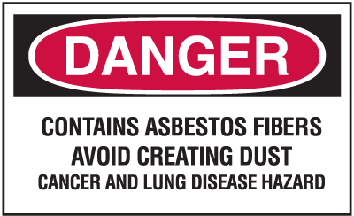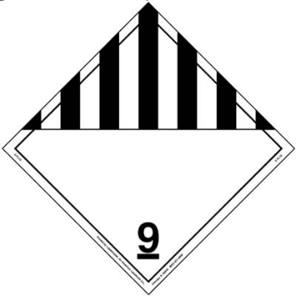
Figure 1 Figure 2

EMPLOYEE TRAINING
All personnel shall receive training or at the least have access to this BMP when dealing with asbestos containing material disposal on Morenci property.
Training will be provided by Supervisor and/or Team Environmental Coordinator.

QUESTIONS OR NEED HELP? CONTACT:

Environmental Representatives and/or Environmental Services Office: 865-6000

