

**Resource Management Center – Liability Management**

**HAZARD RECOGNITION**

**The following rules and guidelines apply during your visit to the Resource Management Center. For your personal safety and the safety of others, observe these rules and guidelines at all times.**

**CONFIDENTIALITY AGREEMENT**

While at the Resource Management Center, use of photographic or video equipment or similar technology is prohibited without the express prior written consent of Freeport McMoRan. In consideration for the granting of permission to enter the Resource Management Center, I hereby agree all knowledge and information acquired or otherwise obtained by me relating to the site’s operations may not be used by me for any purpose or divulged to any person other than authorized representatives of the Liability Management Group without the express prior written consent of Freeport McMoRan

**RELEASE AND INDEMNITY**

On behalf of myself, my parent and subsidiary corporations, in consideration for the granting of permission to enter upon the property owned by Freeport-McMoRan, I release and agree to hold harmless and indemnify Freeport-McMoRan, its affiliates, officers, employees, and agents, from and against all claims and all injuries, losses, and damages to any person or property arising out of entry onto the company’s operations from the date of this release.

**HAZARD RECOGNITION AND AVOIDANCE**

* Freeport McMoRan prohibits the use or transport of alcoholic beverages, drugs and narcotics on company property.
* Appropriate PPE must be worn where indicated.
* Stay clear of working mobile equipment as the operator may not see you.
* Observe all No Smoking areas.
* Seatbelts must be worn by the operator and passengers while vehicles are in motion.
* Observe traffic regulatory signs and rules at all times.
* Do not walk under suspended loads. Be alert for slip, trip and fall hazards.
* Use proper eye protection in areas where cutting and welding work is being performed.
* All vehicles 1 ton and over must be chocked
* All vehicles must have the park brake set when parked.
* All vehicles are subject to unannounced inspections at any location on the site.
* Company policy is to arrest and prosecute anyone apprehended for committing theft from the site premises.
* Active Railroad as you enter and leave the premises. Stop and look/listen before crossing

**FIREARMS**

In accordance with A.R.S 12-781, Firearms must be located in your locked vehicle or in a locked compartment on your motorcycle and the firearm must not be visible from outside the motor vehicle or motorcycle.

**Undocumented Aliens (UDAs)**

* On occasion UDAs may be encountered on or around the site property
* If this should occur do not approach UDAs by yourself
* Instead, immediately report the situation to a Liability Management employee, and they will follow proper reporting procedures

**Animals & Wildlife**

* Be aware and on the lookout for snakes, scorpions, spiders, or other dangerous wildlife that may be encountered while on property
* If an animal is encountered, immediately report the location of the animal to a Liability Management employee, and they will follow proper reporting procedures
* If an animal is found to be injured, deceased or in danger
  + Do not approach, handle, or remove the animal
  + Note its’ location and condition and report it to a Liability Management employee

**Emergency Situations**

* In the event of an emergency situation, an alarm will sound and all employees, visitors and contractors are to report to the muster point.
* 911 is our emergency response number
* Notify site personnel if an emergency occurs in your area

**SAFETY SHOWERS/EYE WASH STATIONS**

Safety showers and eye wash stations are located within the lab area. In the event you are exposed to a hazardous chemical or substance, proceed to the nearest safety shower and flush with water immediately for a minimum of 15 minutes, then seek medical attention.

**PHONE NUMBERS**

* Emergency: 9-911 (from any land line) (911 from Cell Phone)
* Site Directors: Dan Ramey 520-730-3238 and Tom Calhoun 520-820-3697
* Health and Safety Manager: Jill Schultz 520-305-5404
* Training Supt/Sr Health and Safety Lead: Stan Walkup 575-545-3683

**FATAL RISKS PRESENT AT THE RESOURCE MANAGEMENT CENTER**

These symbols indicate a fatal risk may be present in the area. Please consult with local leadership before proceeding to ensure all critical controls are in place to prevent any serious incidents from occurring.

|  |  |  |
| --- | --- | --- |
| FRMIcon_Drowning | FRMIcon_EntangleCrushing | FRMIcon_ContactElectricity |
| Drowning | Entanglement and Crushing | Exposure Electrical Hazards |
| FRMIcon_ConfinedSpaces | FRMIcon_VehicleCollision | FRMIcon_VehicleImpactPerson |
| Confined Spaces | Vechicle Collision or Rollover | Vehicle Impact on Person |
| FRMIcon_FallFromHeight | FRMIcon_FallingObjects | FRMIcon_Fire |
| Fall from Heights | Falling Objects | Fire |
| FRMIcon_UncontrolledRelease | FRMIcon_ExposureAcute | FRMIcon_ExposureChronic |
| Uncontrolled Release of Energy | Hazardous Substance – Acute Exposure | Hazardous Substance – Chronic Exposure |
|  | FRMIcon_LiftingOps |  |
| Rail Collision | Lifting Operations |  |
|  |  |  |
|  |  |  |
|  |  |  |
|  |  |  |

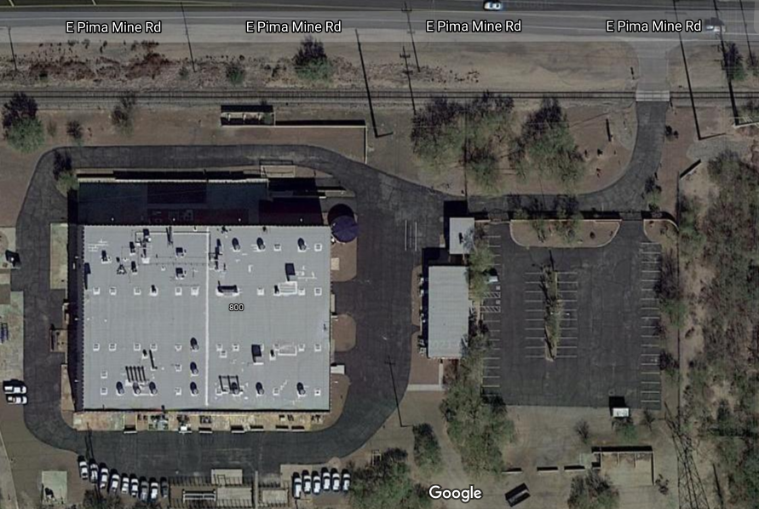

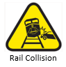

Green Houses (Future)

Training Room

Lab, 2nd Floor

Offices, 2nd Floor

Muster Point (Flagpole)

Admin Office

Safety & Training Bldg

Active Railroad

The printed pamphlet is an uncontrolled document. Visit the DOHS SharePoint site for current version

Version 2, Updated: 04/15/21