|  |
| --- |
|  |
| **Addendum to the Corporate Control of Hazardous Energy Policy** |
| (FCX-HS04) August 2024 |

All energy isolation (LOTOTO) locks will be colored plastic bodied safety locks. Other locks are not acceptable for energy isolation with no exception. These locks shall not be used for any purpose other than LOTOTO. A single lock or keyed alike locks will have only one key. This key is to be kept in the possession of the authorized individual. Spare keys will be destroyed.

* Lock colors by department:
  + Operations: **GREEN**
  + Maintenance: **RED**
  + Admin: **PURPLE**
  + Electrical: **YELLOW**
  + ECC: **ORANGE**

All LOTOTO locks will have an accompanying tag with verbiage containing, but not limited to “Danger” “Locked Out”. Tags can either be stickered to the lock or a secondary tag attached to the lock. Tags will include first and last name of the owner and either their applicable department or their company phone number (if issued).

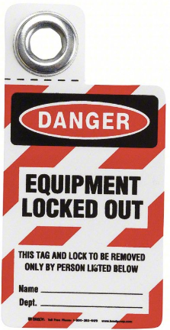 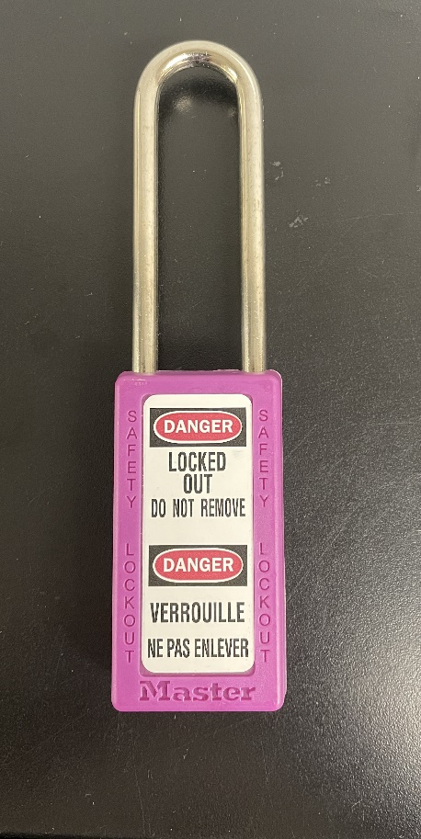

When a lock box is used, the Energy Control Coordinator (ECC) process shall be followed. The ECC form shall be kept at the lock box, except during the ECC transfer process. If an electronic ECC form is being used it shall be readily available/accessible for review.

Personal locks shall not be utilized as ECC locks. If the Energy Control Coordinator is performing work on the system they are ECC for, they shall place their personal LOTOTO lock on the group lockout along with the ECC lock they are in charge of. The Energy Control Coordinator shall maintain the ECC key in their possession at all times, except for when they have transferred ownership of the ECC lockout to a new Energy Control Coordinator.

|  |  |
| --- | --- |
| Date of Changes | Summary of Changes |
| August 2024 | Reformatted. Removed description of tag IDs. Removed information referenced in current corporate policy and out of date policy information. |
|  |  |
|  |  |
|  |  |
|  |  |
|  |  |