Miami Operations – Elevate your Eye Protection

In an effort to reduce the number of eye injuries at Miami Operations, we are elevating our eye protection requirements. Effective October 1, 2024, it will be MANDATORY for all employees to be equipped with one of the five options below at all times while in the field.

1. A pair of safety goggles

   Description automatically generatedSpoggles - Sealed Eyewear (prescription

**Stock Codes:**

3M – 40755931

Pyramex - 40764034

glasses see Kathy Roberts)

*New Milwaukee hard hats have a face shield that is made for the hard hat*

1. Regular safety glasses with a

**Stock Codes:**

Face Shield – 40764184

Shield Mount - 40764032

face shield on and down

**Stock Code:** 40753387

**Stock Code:** 40753388

Elevatd Eye

1. 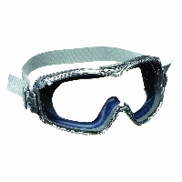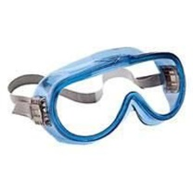Goggles

Uvex Stock Code: 40134092

Kleenguard Stock Code: 40009184

1. Full Face respirator (available at the Hygiene Center upon request)
2. PAPR (when deemed necessary for the

task, available at the Hygiene Center

Deadline to comply with new requirements – October 1, 2024. ***Do not wait until the last minute!***

upon request)