|  |  |
| --- | --- |
| Miami Site Wide Operations | Issued: 6/11/20 |
| Lightning Procedure | Revision Date  03/25/2024 |
| Manager’s Approval  03/28/2024 |

**SAFE OPERATING PROCEDURES**

**FOR**

**Lightning Alerts**

**SCOPE**

To provide safe guidelines for lightning detection and action

# SAFETY

All Miami

Alerts can change between green, yellow and red alerts within minutes. The lightning detection system is a tool to guide actions for personal safety. **Based on your location, you may be closer or further from the storm than the detection, system indicates. Personal awareness is your best safety device to determine actions. Outside work shall not be performed during Red Alert conditions. Minimal travel between vehicles and buildings or between one building to another building or to your vehicle may occur using cautious judgement in determining if there is nearby lightning activity. Vehicle is defined as having a fully enclosed cabs. Handheld Lightning Detection units are not to be used.**

# ENVIRONMENTAL

No known environmental aspects are associated with this Safe Operating Procedure. Comply with State, Federal and Company Policy.

# TOOLS AND ADDITIONAL PPE REQUIRMENTS

* Miami Contrail/Earth Networks Lightning Detection Share Point site.
* Radio/Telephone communication/Computer Email
* Sferic Sirens
* Dispatch/Two way radio Red Alert System
* Red alert tone every two minutes (Reminder we are still under Red Alert)

If the Contrail/ Earth Networks Lightning Detection system indicates changing weather, Main gate/ Dispatch will log on the Miami Home Page, select the Miami Tab and select Lightning Alert -Contrail Link located in the quick links on the Miami home page. The maps will update every 30 seconds.

# Figure 1 – Miami SharePoint Page

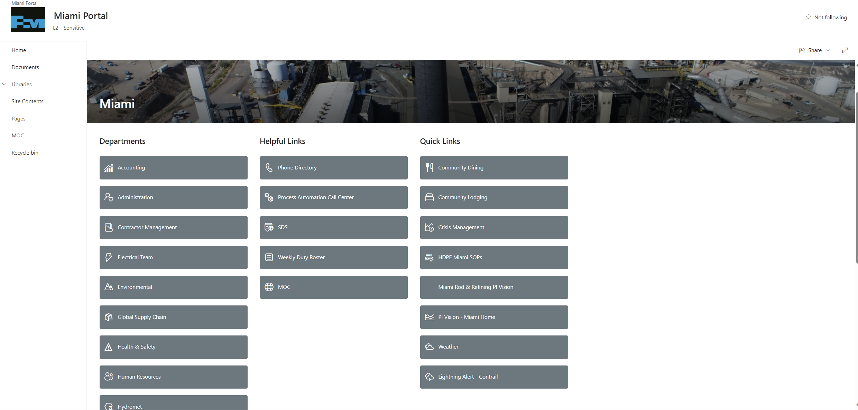

# Figure 2 – Lightning Alert Dashboard With Map, Rings, and Active Alarms Widget

**NOTE: Miami employees and contractors desiring Red Alert notification via e-mail or text can get access by contacting Security and providing email/phone number. For access to the Contrail/ Earth Networks system, you can put in a ticket to the Help Desk.**

**Sferic Sirens**

Devices that have a warning strobe light and sound a siren to those working in the area to indicate Red Alert lightning status. All operations units function 24/7. There are two units at CVRC. These will function during normal business hours.

Green/ All Clear

* All Clear for lightning

**Yellow Alert**

* Lightning detected within 15 miles
* Indicates weather is worsening, the Main gate/ Dispatch will announce that the severity has elevated and that we are now under a “Yellow Alert”
* Area personnel should be aware that a Red Alert may occur soon and to take appropriate steps to minimize their lightning exposure
  + Operations, maintenance, ground crews and all other personnel in the field may elect to move away from large metal machines, lower cranes or vacate open areas.
* Control Rooms will announce the alerts over the Gai-tronics where appropriate

**Red Alert**

* Lightning detected within 6 miles
* Once under the "Red Alert" Main gate/ Dispatch will activate the Red Alert tone over the two-way radio which will beep every two minutes to notify employees that we are still under Red Alert.
* The Tone will be patched to and tone on the channels listed below.
  + Mine, Dump leach, Tankhouse, and Smelter Ops, Security, GSC, Rod Plant, Recreation Center,
* The SX Control Room Operator will announce over the radio on the DL channel that the area is under “Red Alert” and will contact the EW Control room by phone
* Control Rooms will announce the alerts over the Gai-tronics where appropriate
* Sferic Sirens will sound a 15 second blast.
* The strobe will start to flash.
* Anyone outside must find shelter and wait out the storm until the Mine SX Control Room Technicians issue a “Yellow Alert” or “All Clear” (green stage) announcement
* Shelter includes vehicles, equipment cabs, shops and buildings.
  + Vehicles and equipment must have a fully enclosed cab to be considered shelter.
* You should not travel in the open if lightning is detected within 6 miles.
  + Minimal travel between vehicles and buildings or between one building to another building may occur using cautious judgement in determining if there is nearby lightning activity.
  + Generally, you should not travel in the open more than 100 feet if lightning is still detected within 10 miles.
    - For example, travel from the smelter buildings to the main employee parking lot is to too far for safe travel with lightning nearby.
  + Similarly, employees reporting to work should remain in their vehicles during a Red Alert until it is obvious the lightning is no longer nearby (greater than 10 miles away). Contact your supervisor if in doubt.

* Once the Red Alert is cleared or reduced to Yellow Alert the Main Gate/Dispatch will notify personnel via radio and turn the tone off.
  + The Control Rooms will announce status over the radio and Gai-tronics
  + The Sferic Sirens will sound three 5 second blasts and the strobes will shut off.

**NOTE: Miami employees desiring Red Alert notification via e-mail can do so by entering a Help Desk ticket for MIS to complete. Miami employees and contractor supervisors desiring Red Alert notification via text messaging can do so by contacting the Health and Safety department.**

