Entanglement Hazards and the Hierarchy of Control 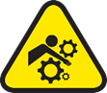

Industrial environments contain machinery and process that have moving parts. Unwanted contact with moving machine parts can cause serious or fatal injuries. We all have a role to play in ensuring that we minimize the potential for contact with moving machine parts.

Utilizing the hierarchy of control, the most effective way to guard against becoming entangled in moving machine parts that are necessary in the industrial environment is to engineer controls to prevent contact or entanglement. Properly constructed and installed guards can prevent contact with moving machine parts.

Unfortunately, fatalities still occur around moving machine parts.

- February 23, 2017, Cerro Verde Operations: A contract Orica employee was fatally injured when he became entangled in the tail pulley of the Ammonium Nitrate silo feed belt. The employee, for an unknown reason, passed the outer Restricted Area barrier, removed the machine guard around the tail pulley, passed behind the screen when the machinery caught the arm of the employee and pulled the employee into the machinery.

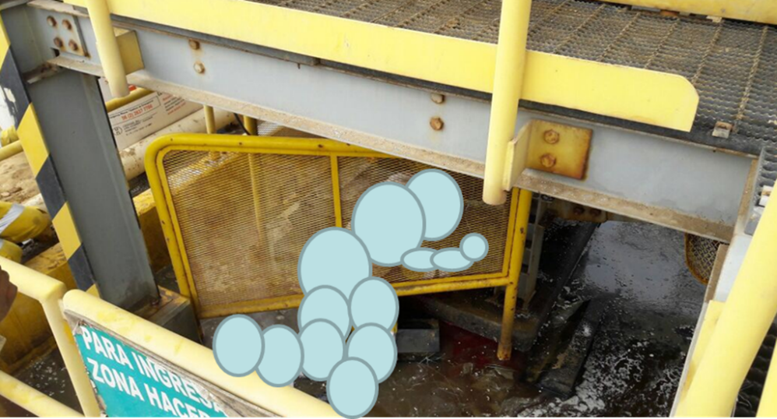

Management Responsibility: Provide resources to allow the effective training for all employees that could be exposed to moving machine parts and the necessary resources to correct these hazards. Monitor work activities to ensure that employees are following established procedure around moving machine parts. Periodically verify that effective critical controls are in place.

Supervisor Responsibility: Ensure that employees are properly trained for the tasks they will perform and that proper workplace exams are completed. Create an atmosphere where employees understand the STOP WORK Authority to implement field controls to complete tasks safely. Establish safe work procedures through collaboration with the crews doing the work.

Employee Responsibility: Identify areas where people could potentially contact moving machine parts and install guarding to prevent incidental contact. Once guards are in place, evaluate for effectiveness and continually inspect to ensure they remain in place and are secure. Promptly report missing, removed, loose, or damaged guards. Conduct thorough workplace exams and JSAs (AROs) to identify entanglement hazards. Where inadvertent contact is likely with an upset guard, STOP WORK!
- Exercise personal responsibility. Never bypass a guard and utilize LOTOTO when performing work on machinery. Block against hazardous motion. Do not wear loose clothing or jewelry around moving machine parts that could become entangled, including fall arrest lanyards.

On 1/6/2012 (Friday), at about 6:30 PM, a contract driller helper was preparing to climb the drill derrick. As he started the climb, his safety lanyard, which was trailing behind him, became tangled in the drill's drawork shaft. The drawork shaft drew him into the machinery causing crushing and high blood pressure-related injuries.
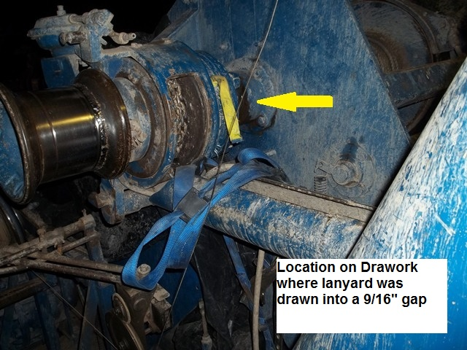
References and Tools:
- LOTOTO Policy.pdf
- FCX Material Handling Conveyance Policy Oct 16.pdf
- Workplace Examination Training Docs
- Contractor Safety Manual
- 30 CFR Part 56/57

