Week 2. Managing Tasks around Entanglement Hazards

We are all responsible to manage the risk of coming in contact with moving machine parts. The consequences of becoming entangled in moving machine parts can be catastrophic. How we manage these fatal risks as a work group is extremely important.

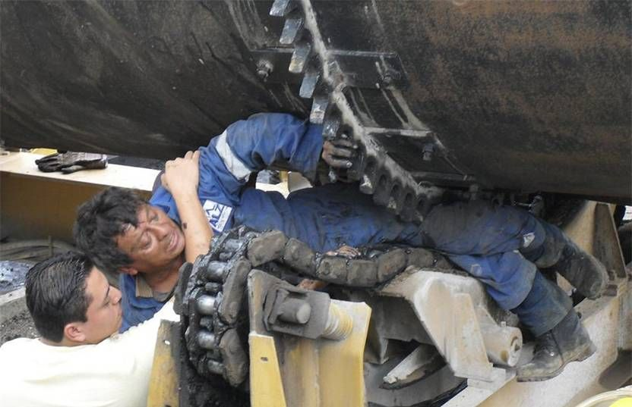

- What tasks are we going to perform today that have an entanglement risk involved?
- What controls do we have in place for that task to ensure we will not become entangled in moving machine parts?
- How do we verify that the controls are in place and effective?
  - Whose responsibility is it to verify controls?
- How often do we verify or audit that the controls are still effective throughout the task?
- What are we going to do if we find that one of the controls is missing or is no longer effective because the job has changed?
- Is there anything else that we can do to reduce the entanglement risks of the task?

