Last week we talked about auditing and the value it can bring to an organization. The objective of any audit is risk reduction and moving controls up the hierarchy. The following are some outstanding critical control upgrades that have been implemented by our employees due to auditing and the input of subject matter experts. These ideas do not have to always be elaborate or expensive and show examples of reducing the risk of interacting with moving equipment.

During a routine field inspection an employee was observed in the line of fire while assisting a light vehicle driver with backing up to a trailer.
A trailer alignment kit was purchased to eliminate the need for employees to be behind vehicles that are backing up. The trailer alignment kit consists of foam balls on the end of a tele- scoping magnetic rod. The magnetic bases are placed on the trailer tongue and the receiver

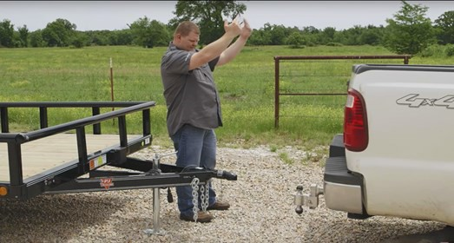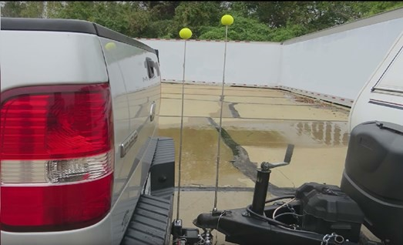
Without Controls
Controls which eliminate exposure

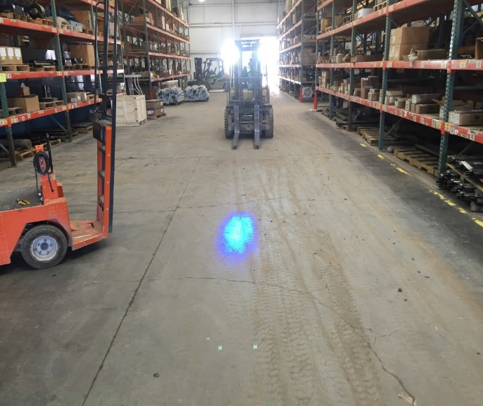
On November 7th 2016 a Potential Fatal Event Advisory was published from El Paso which described a truck driver
stepping into the path of a forklift operator. The question was then asked, “Can that occur at my property” This led to an audit of the facility. Morenci did in fact, find that the forklifts that operate in our warehouse are very quiet and in fact the exact same
condition existed. Management worked in collaboration with the critical control improvement team member to assist us with a solution. The engineer researched various options and provided a cost effective, efficient solution. The blue lights are currently being evaluated in the warehouse. They warn an employee of approaching forklifts and were very inexpensive.

