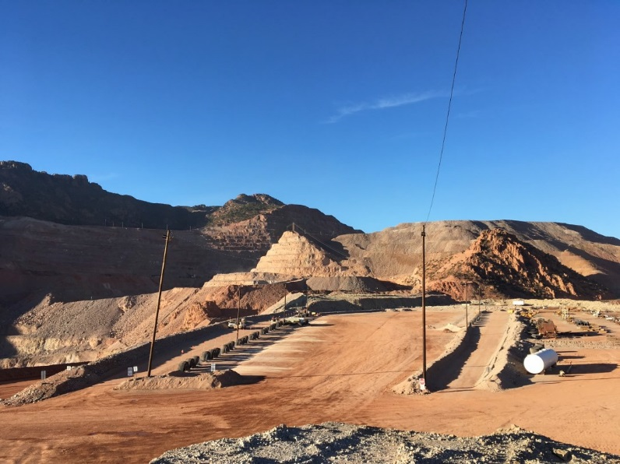
Heavy equipment ready lines pose great risks to ground personnel and light vehicles carrying multiple opera- tors.
To reduce the exposure to personnel ready lines have been re-designed to keep people and light vehicles away from haul trucks.
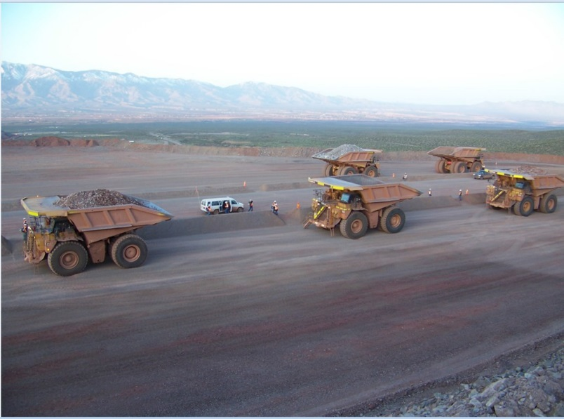

Something as simple as a one way round about or a center berm in the haul road can greatly reduce the chances of two haul trucks colliding.

With each publication of a Potential Fatal Event, all areas have an opportunity to ensure the critical controls are in place, being utilized and are effective in preventing a similar event. Auditing can provide you with verification that this risk is either well managed or allow you to put additional controls in place. Each and every potential fatal alert offers a unique opportunity to improve!!

